List of Advanced Learners and Slow Learners (2021-22)
BFA-1stSem
(Fine Arts Dept.)
Advanced learners are those students who are university toppers/ active in participation in activities/conferences/societies, have publications/cleared competitive exams, enrolled in online courses etc.
 | Advanced Learners
Name of Student | College Roll No. | Class | Marks in University Exams/House Tests in Previous year/Semester | Member of any society/ organization etc. | Measures Taken/opportunities given to Further enhance skills and confidence of the students | Achievements/ Outcome | Proof of the achievement/ outcome
Reeva SharmaYangchanDolker  IshaPachya  Alina | 54057  54071  54056  54068 | BFA-1TH SEM  BFA-1TH SEM  BFA-1TH SEM  BFA-1TH SEM | 378/400  369/400  362/400  362/400 | Joint Secretary |  | 1st in GNDU  5th in GNDU  9th in GNDU  9th in GNDU | 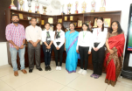

Slow Learners
Name of Student | Roll No. | Class | Marks in University Exams/House tests | Remedial Measures Taken | Outcome/ Achievements | Proofs (if any)
Setika | 54062 | BFA-1st SEM | 309/400 | Basic skills education, preparatory education, and academic upgrading | Identify a range of works of Art and Artists | 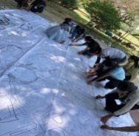
Yukta | 54061 | BFA-1stSEM | 258/400 | Improve of Drawing and Painting | Detail knowledge of Coloring | 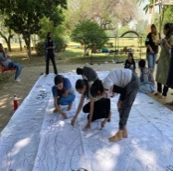
Teena | 54061 | BFA-1stSEM | 300/400 | Knowledge of  Perspective | Digital painting and CAD | 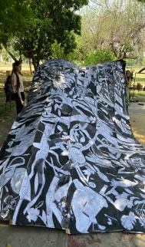

List of Advanced Learners and Slow Learners (2021-22)
BFA-2nd Sem
(Fine Arts Dept.)
Advanced learners are those students who are university toppers/ active in participation in activities/conferences/societies, have publications/cleared competitive exams, enrolled in online courses etc.
 | Advanced Learners
Name of Student | College Roll No. | Class | Marks in University Exams/House Tests in Previous year/Semester | Member of any society/ organization etc. | Measures Taken/opportunities given to Further enhance skills and confidence of the students | Achievements/ Outcome | Proof of the achievement/ outcome
Reeva Sharma  YangchanDolker | 54057  54071 | BFA-2nd SEM  BFA-2nd SEM | 732/800  738/800 |  |  | 2nd in GNDU  1st in GNDU | 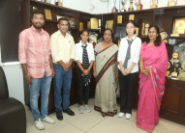

Slow Learners
Name of Student | Roll No. | Class | Marks in University Exams/House tests | Remedial Measures Taken | Outcome/ Achievements | Proofs (if any)
Setika | 54062 | BFA-2nd S. | 635/800 | Basic skills education, preparatory education, and academic upgrading | Identify a range of works of Art and Artists
Yukta | 54061 | BFA-2nd S. | 613/800 | Improve of Drawing and Painting | Detail knowledge of Coloring
Teena | 54061 | BFA-2nd S. | 612/800 | Knowledge of  Perspective | On the spot Drawing and painting

List of Advanced Learners and Slow Learners (2021-22)
BFA-3rd Sem
(Fine Arts Dept.)
Advanced learners are those students who are university toppers/ active in participation in activities/conferences/societies, have publications/cleared competitive exams, enrolled in online courses etc.
 | Advanced Learners
Name of Student | College Roll No. | Class |  |  | Marks in University Exams/House Tests in Previous year/Semester |  | Member of any society/ organization etc. | Measures Taken/opportunities given to Further enhance skills and confidence of the students |  | Achievements/ Outcome |  | Proof of the achievement/ outcome
Bhavya | 54001 | BFA-3rd SEM |  |  | 574/600 |  | CR |  |  | 2nd in GNDU |  | 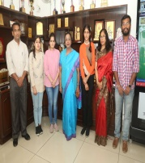
Bhavna | 54009 | BFA-3rd SEM |  |  | 557/600 |  |  |  |  | 3rd in GNDU
Saman deep Kaur | 54005 | BFA-3rd SEM |  |  | 536/600 |  |  |  |  | 10th in GNDU
Slow Learners
Name of Student |  |  | Roll No. | Class |  | Marks in University Exams/House tests |  |  | Remedial Measures Taken |  | Outcome/ Achievements |  | Proofs (if any)
Harshita |  |  | 54007 | BFA-3rd SEM |  | 394/600 |  |  | Basic skills education, preparatory education, and academic upgrading |  | Identify a range of works of Art and Artists |  | 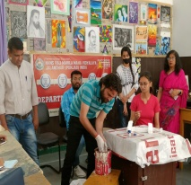
Priya |  |  | 54010 | BFA-3rd SEM |  | 455/600 |  |  | Improve of Drawing and Painting |  | Detail knowledge of Coloring |  | 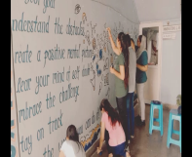
Deepti |  |  | 54003 | BFA-3rd SEM |  | 451/600 |  |  | Knowledge of  Perspective |  | Digital painting and CAD |  | 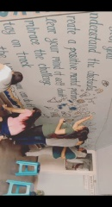

List of Advanced Learners and Slow Learners (2021-22)
BFA-4th Sem
(Fine Arts Dept.)
Advanced learners are those students who are university toppers/ active in participation in activities/conferences/societies, have publications/cleared competitive exams, enrolled in online courses etc.
 | Advanced Learners
Name of Student | College Roll No. | Class | Marks in University Exams/House Tests in Previous year/Semester | Member of any society/ organization etc. | Measures Taken/opportunities given to Further enhance skills and confidence of the students | Achievements/ Outcome | Proof of the achievement/ outcome
Bhavya | 54001 | BFA-4th SEM | 1132/1200 | CR |  | 1st in GNDU
Bhawna | 54009 | BFA-4th SEM | 1069/1200 |  |  | 6th in GNDU

Slow Learners
Name of Student | Roll No. | Class | Marks in University Exams/House tests | Remedial Measures Taken | Outcome/ Achievements | Proofs (if any)
Harshita | 54007 | BFA-4th SEM | 750/1200 | Basic skills education, preparatory education, and academic upgrading | Identify a range of works of Art and Artists
Priya | 54010 | BFA-4th SEM | 885/1200 | Improve of Drawing and Painting | Detail knowledge of Coloring
Deepti | 54003 | BFA-4th SEM | 886/1200 | Knowledge of  Perspective | Digital painting and CAD

List of Advanced Learners and Slow Learners (2021-22)
BFA-5THSem
(Fine Arts Dept.)
Advanced learners are those students who are university toppers/ active in participation in activities/conferences/societies, have publications/cleared competitive exams, enrolled in online courses etc.
 | Advanced Learners
Name of Student | College Roll No. | Class | Marks in University Exams/House Tests in Previous year/Semester | Member of any society/ organization etc. | Measures Taken/opportunities given to Further enhance skills and confidence of the students | Achievements/ Outcome | Proof of the achievement/ outcome
TavleenKaur | 4626 | BFA-5thSem | 578/600 |  |  | 2nd - in GNDU | 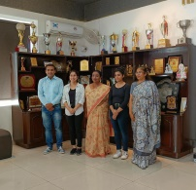
Kanishka | 4631 | BFA-5th Sem | 577/600 | Secretary |  | 3rd in GNDU
Sheena | 4628 | BFA-5th Sem | 575/600 |  |  | 4th in GNDU
Plasha | 4623 | BFA-5th Sem | 568/600 | CR |  | 5th in GNDU
Loveleen | 4624 | BFA-5th Sem | 554/600 |  |  | 7th in GNDU
Nishtha | 4621 | BFA-5th Sem | 552/600 |  |  | 8th in GNDU

Slow Learners
Name of Student | Roll No. | Class | Marks in University Exams/House tests | Remedial Measures Taken | Outcome/ Achievements | Proofs (if any)
Diksha | 4622 | BFA-5TH SEM | 443/600 | Basic skills education, preparatory education, and academic upgrading | Identify a range of works of Art and Artists | 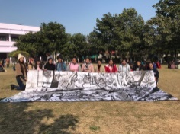
Twinkle | 4625 | BFA-5TH SEM | 461/600 | Improve of Drawing and Painting | Detail knowledge of Coloring | 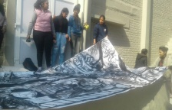

List of Advanced Learners and Slow Learners (2021-22)
BFA-6th Sem
(Fine Arts Dept.)
Advanced learners are those students who are university toppers/ active in participation in activities/conferences/societies, have publications/cleared competitive exams, enrolled in online courses etc.
 | Advanced Learners
Name of Student | College Roll No. | Class | Marks in University Exams/House Tests in Previous year/Semester | Member of any society/ organization etc. | Measures Taken/opportunities given to Further enhance skills and confidence of the students | Achievements/ Outcome | Proof of the achievement/ outcome
Kanishka | 4631 | BFA-6th Sem | 1120/1200 | Secretary |  | 2nd - inGNDU | 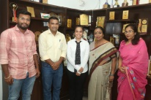
Plasha | 4623 | BFA-6th Sem | 1108/1200 | CR |  | 3rd in GNDU
Sheena | 4628 | BFA-6th Sem | 1095/1200 |  |  | 5th in GNDU
Tavleen | 4628 | BFA-6th Sem | 1092/1200 |  |  | 6th in GNDU

Slow Learners
Name of Student | Roll No. | Class | Marks in University Exams/House tests | Remedial Measures Taken | Outcome/ Achievements | Proofs (if any)
Diksha | 4622 | BFA-6th Sem | 847/1200 | Basic skills education, preparatory education, and academic upgrading | Identify a range of works of Art and Artists
Twinkle | 4625 | BFA-6th Sem | 899/1200 | Improve of Drawing and Painting | Detail knowledge of Coloring

List of Advanced Learners and Slow Learners (2021-22)
BFA-7THSem
(Fine Arts Dept.)
Advanced learners are those students who are university toppers/ active in participation in activities/conferences/societies, have publications/cleared competitive exams, enrolled in online courses etc.
 | Advanced Learners
Name of Student | College Roll No. | Class | Marks in University Exams/House Tests in Previous year/Semester | Member of any society/ organization etc. | Measures Taken/opportunities given to Further enhance skills and confidence of the students | Achievements/ Outcome | Proof of the achievement/ outcome
Sujata |  | BFA-7TH SEM | 576/600 | Secretary |  | 2nd in GNDU | 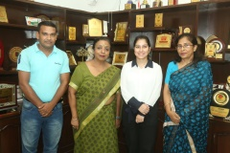
Vrishti |  | BFA-7TH SEM | 573/600 |  |  | 5th in GNDU
Parul |  | BFA-7TH SEM | 564/600 | CR |  | 8th in GNDU

Slow Learners
Name of Student | Roll No. | Class | Marks in University Exams/House tests | Remedial Measures Taken | Outcome/ Achievements | Proofs (if any)
Neena | 4611 | BFA-7TH SEM | 417/600 | Knowledge of  Perspective | Digital painting and CAD | 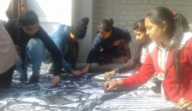
Chahat | 4612 | BFA-7TH SEM | 392/600 | Knowledge of  Perspective | Digital painting and CAD | 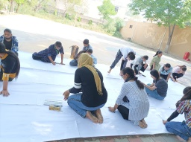
Simranjit | 4610 | BFA-7TH SEM | 472/600 | Knowledge of  Perspective | Digital painting and CAD | 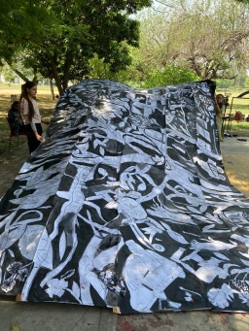

List of Advanced Learners and Slow Learners (2021-22)
BFA-8THSem
(Fine Arts Dept.)
Advanced learners are those students who are university toppers/ active in participation in activities/conferences/societies, have publications/cleared competitive exams, enrolled in online courses etc.
 | Advanced Learners
Name of Student | College Roll No. | Class | Marks in University Exams/House Tests in Previous year/Semester | Member of any society/ organization etc. | Measures Taken/opportunities given to Further enhance skills and confidence of the students | Achievements/ Outcome | Proof of the achievement/ outcome
Sujata | 4606 | BFA-8TH SEM | 4025/4400 | Secretary |  | 1st in GNDU
Vrishti Gill | 4608 | BFA-8TH SEM | 3970/4400 |  |  | 4th in GNDU
Parul | 4604 | BFA-8TH SEM | 3747/4400 | CR |  | 10th in GNDU

Slow Learners
Name of Student | Roll No. | Class | Marks in University Exams/House tests | Remedial Measures Taken | Outcome/ Achievements | Proofs (if any)
Neena | 4611 | BFA-8TH SEM | 3225/4400 | Knowledge of  Perspective | Digital painting and CAD
Chahat | 4612 | BFA-8TH SEM | 3013/4400 | Knowledge of  Perspective | Digital painting and CAD
Simranjit | 4610 | BFA-8TH SEM | 3361/4400 | Knowledge of  Perspective | Digital painting and CAD

